**Installation Instructions**

(1) Install:

Download and install 64 bit [Anaconda](https://www.anaconda.com/download), Python version 3.7. Make sure to select your operating system – Linux/MacOS/Windows. During the installation you will be asked if the installation is for all users or just for you – choose “just me” or “local user”.

(2) Confirm:

Launch anaconda-navigator (find it in Applications on MAC / all programs Windows)

From the navigator window, launch Jupiter Notebook. It will open a window in your default internet browser and a terminal window on mac. We are going to work in the browser, but don’t close the terminal if it is open.

Create new Python 3 notebook (read the notebook navigation basics [here](http://jupyter-notebook.readthedocs.io/en/latest/examples/Notebook/Notebook%20Basics.html) if needed):

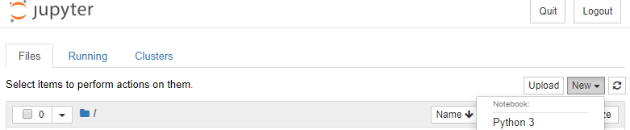

Type the following commands in the command window and press ctrl+return on Mac or alt+enter on Win:

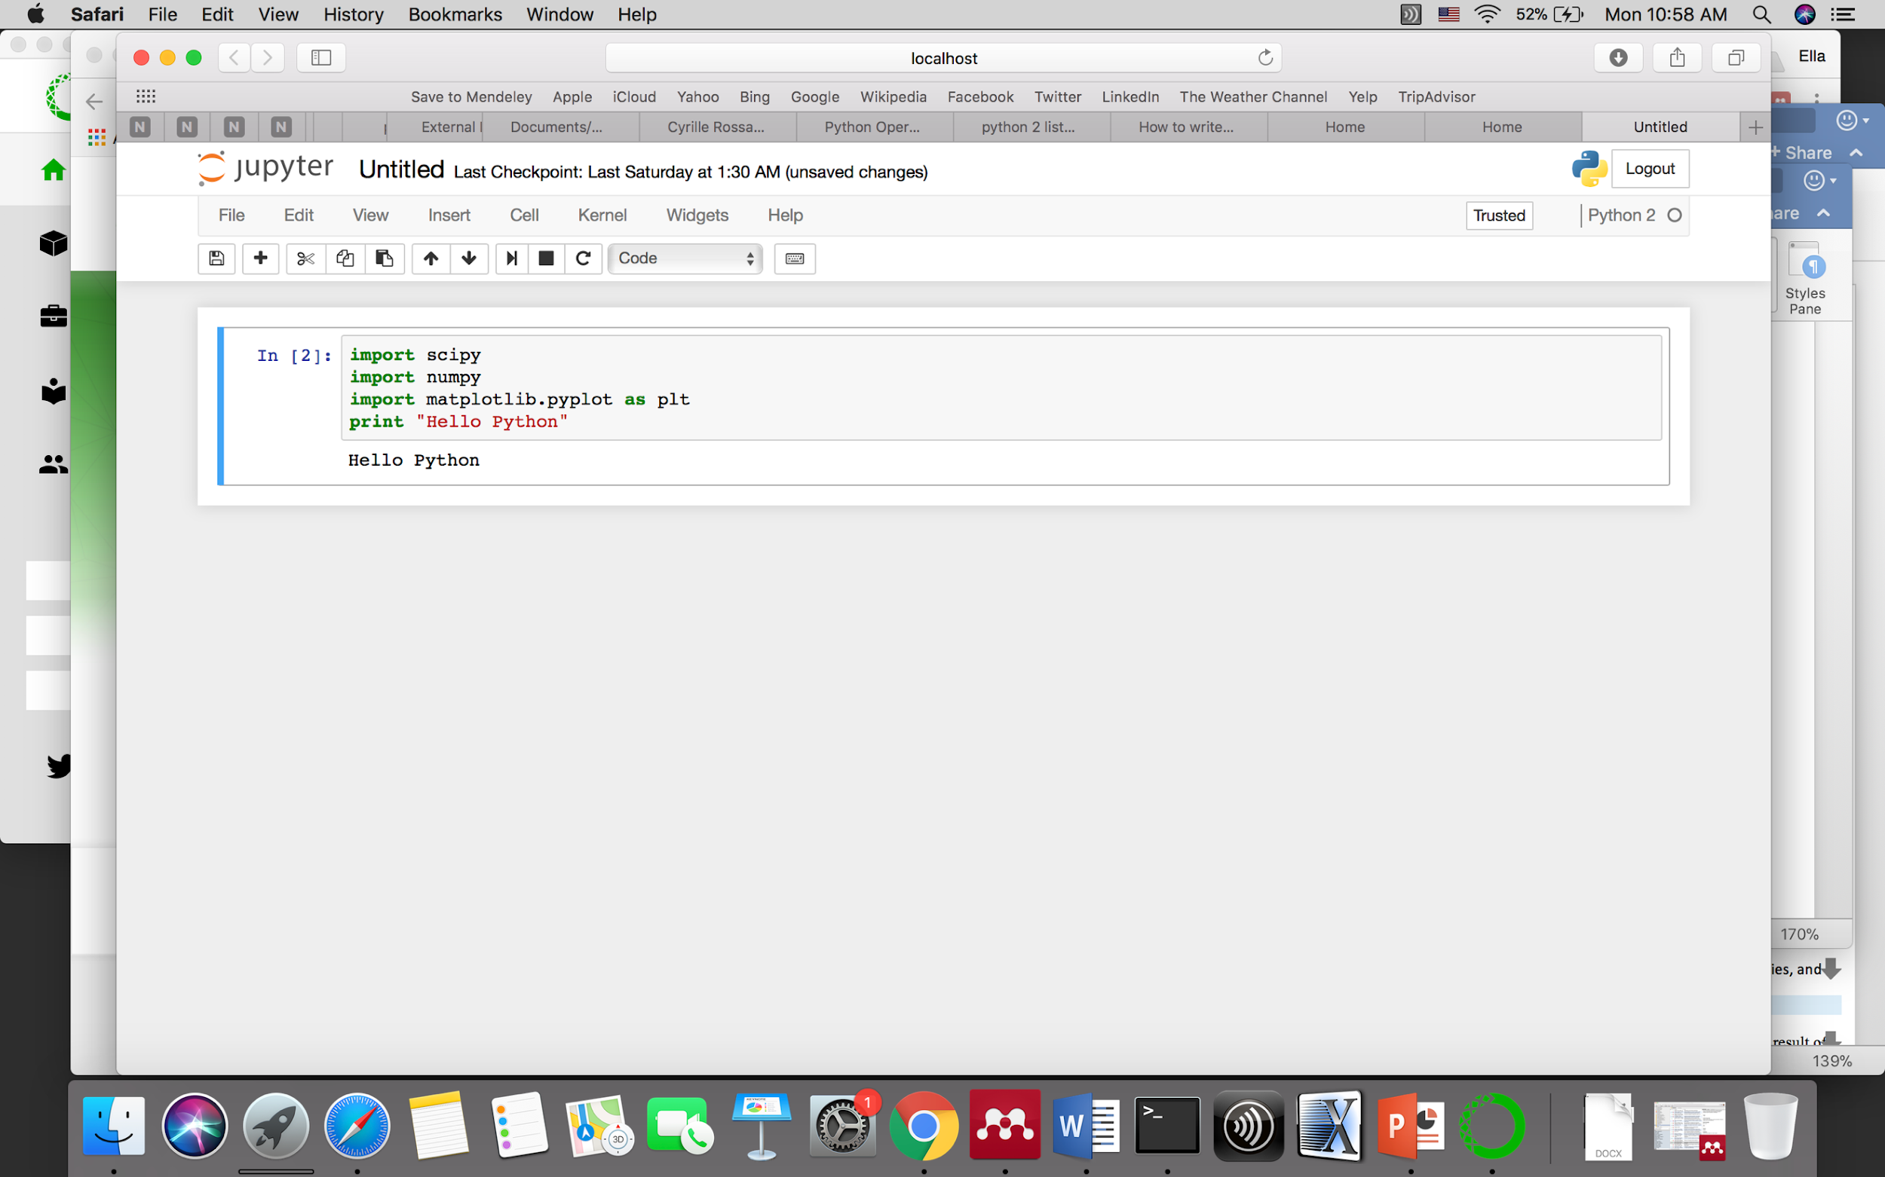

If there are no errors the installation worked.

(3) Latex:

Jupitor notebooks can be used for general text and Latex equations. The text editing language is called markdown. To add a markdown cell press “insert” on the top menu. Select markdown from cell->cell type menu.

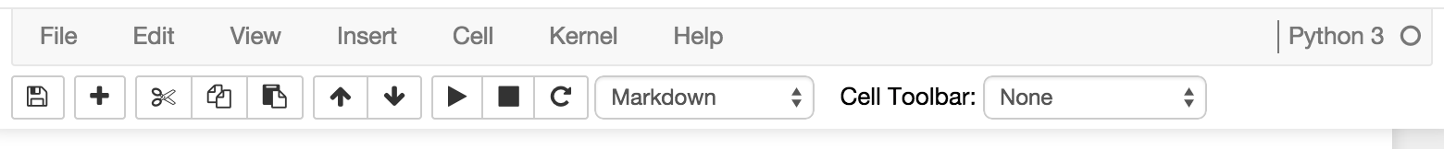

Read [here](http://jupyter-notebook.readthedocs.io/en/stable/examples/Notebook/Working%20With%20Markdown%20Cells.html) how to use it. Read here more about [latex](http://data-blog.udacity.com/posts/2016/10/latex-primer/) equations.

(4) Convert notebook to PDF:

There are few options to convert your notebook to PDF file.

1. Using TeX document preparation ecosystem.

Download and install:

Linux: [TeX Live](http://tug.org/texlive/)

macOS (OS X): [MacTeX](http://tug.org/mactex/).

Windows: [MikTex](http://www.miktex.org/)

Restart anaconda and the terminal.

Run anaconda-navigator, reopen your notebook and convert:

File🡪Download as🡪PDF via LaTeX

This is the preferred method. If it doesn’t work – tell us.

1. If method (a) doesn’t work and you must submit your homework, open your notebook and use:

File🡪Print Preview🡪Print page as pdf